Instructions for fitting a bill reader to a Teide Blue machine.

- Ensure you have the necessary parts – see the “bill reader information” file in the technical support section of the website for a summary of parts.
- Power down machine;
- Connect one end of the IF5 grey ribbon cable to the bill reader and connect the other end to the IF5 box as per the photo below;
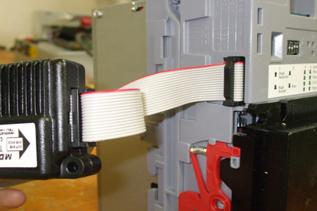
Step 3 – connecting the IF5 ribbon cable to the NV9

- Connect the black plug of the IF5 cable to the IF5 box as per the photo below;
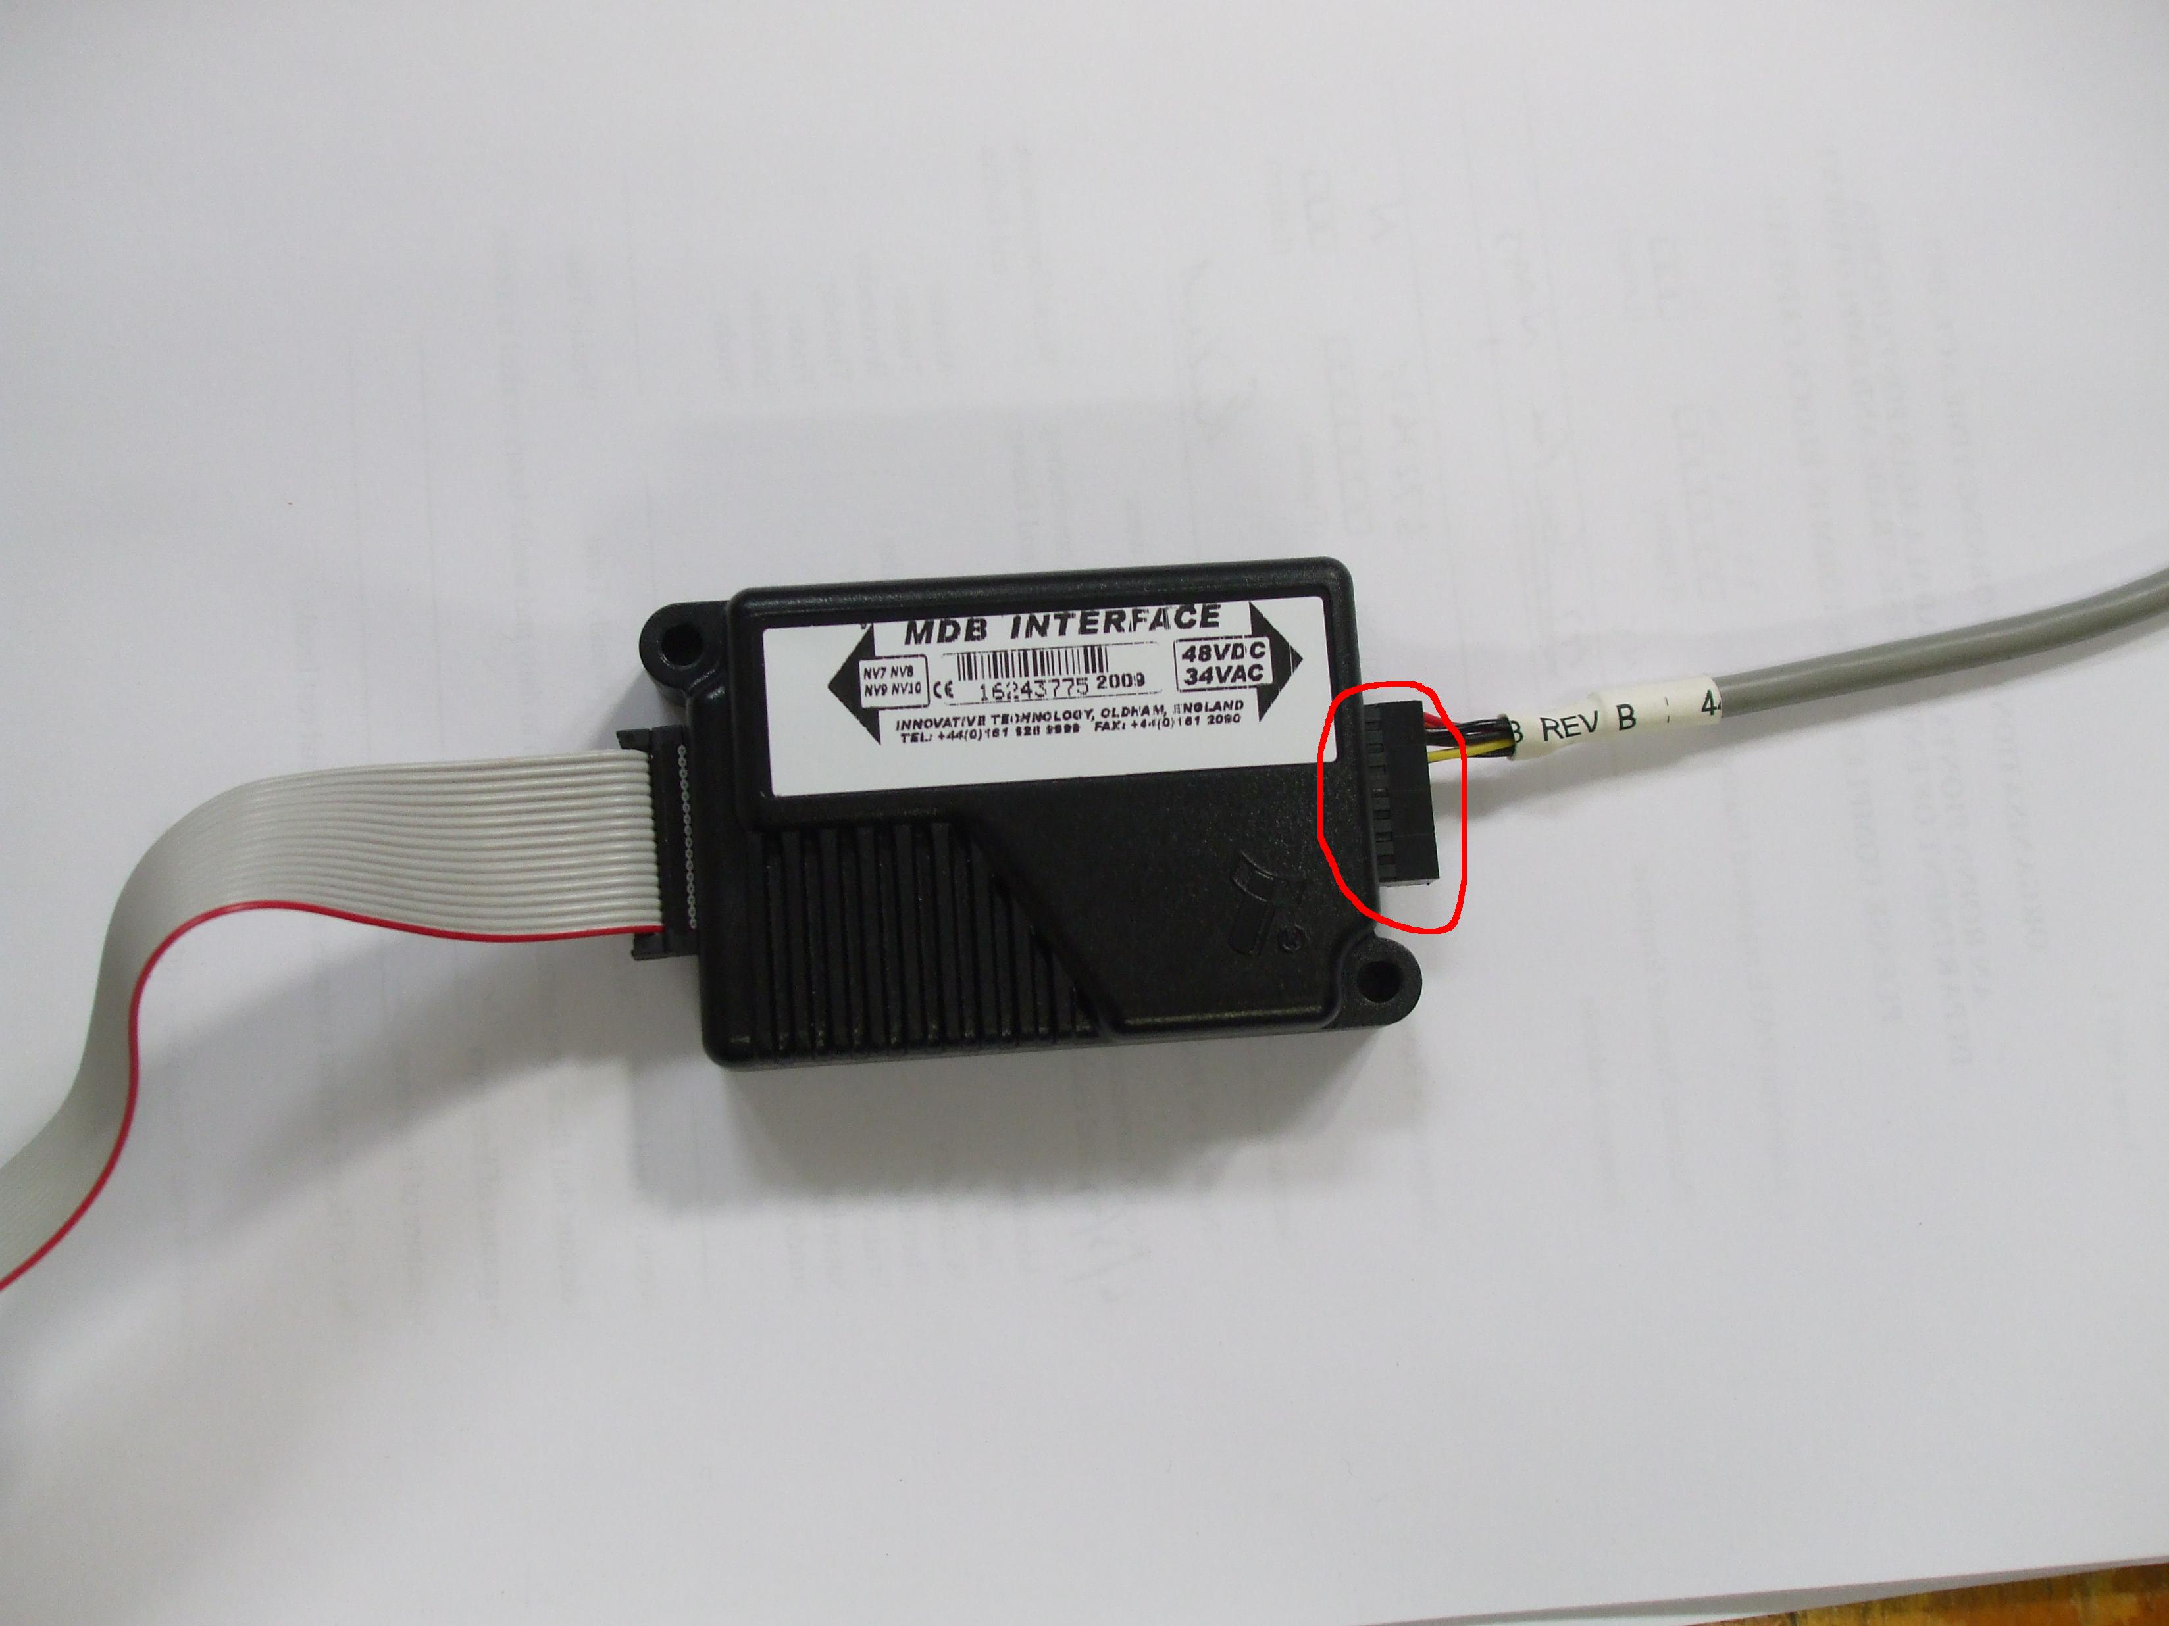
Step 4 – connecting the IF5 cable to the IF5 box

- The IF5 cable has two white connectors – one male and one female. Connect the male connector on the IF5 cable to the female connector on the MDB loom (the MDB loom will already be in the Teide Blue). There is no need to connect the female end of the IF5 cable to anything. See photo below;
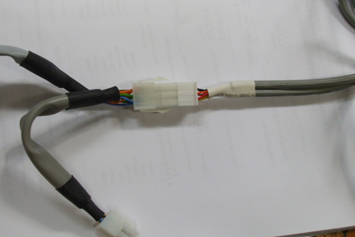
Step 5 – connecting the IF5 cable to the MDB loom

- Power up the machine;
- Hold down button “C” on the handset for 4 seconds and release. “Function 000” will appear on the display. Enter in function number 455 by pressing C 4 times, B 5 times and A 5 times. When “function 455” is on the display press the reject button to enter the programme.
- “No bill reader” will appear on the display. Press button A and “MDB” will appear. Press button “D” to confirm.
- Press reject and “Escrow” and either “yes” or “no” will appear;
- NB – If the machine is for use in a pub then set this to “yes;
- NB – If the machine is for use in a shop then set this to “no”;
- Press reject and “ACC O-OF-Chg No” will appear on the display, press reject button;
- “Bill 5.00 Yes” will appear – if you wish the bill reader to accept €5 notes then leave this on “yes”. If you do not then press A to change to “Bill 5.00 No”. When you have made your choice press reject – NB – if machine is for use in a pub then only €5 should be turned on;
- Repeat the above for €10, €20 and €50 notes;
- When you press reject after the €50 note setting the machine will return to normal mode.

During use:
If you wish to check what money should be in the note reader at any point, go to programme #149 “money in notes” by holding down button C . Press D to enter the programme. Use programme # 171 “count reset” to clear the data if you wish.

