Instructions for fitting a bill reader to a Vendtech machine.
- Ensure you have the necessary parts – see the “bill reader information” file in the technical support section of the website for a summary of parts.
- Power down machine;
- Connect one end of the IF5 grey ribbon cable to the bill reader and connect the other end to the IF5 box as per the photo below;
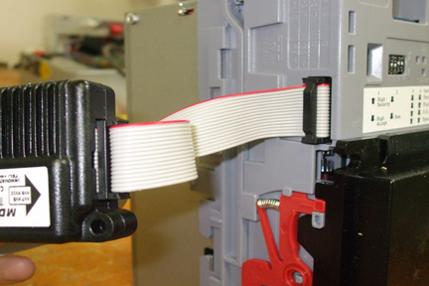
Step 3 – connecting the IF5 ribbon cable to the NV9

- Connect the black plug of the IF5 cable to the IF5 box as per the photo below;
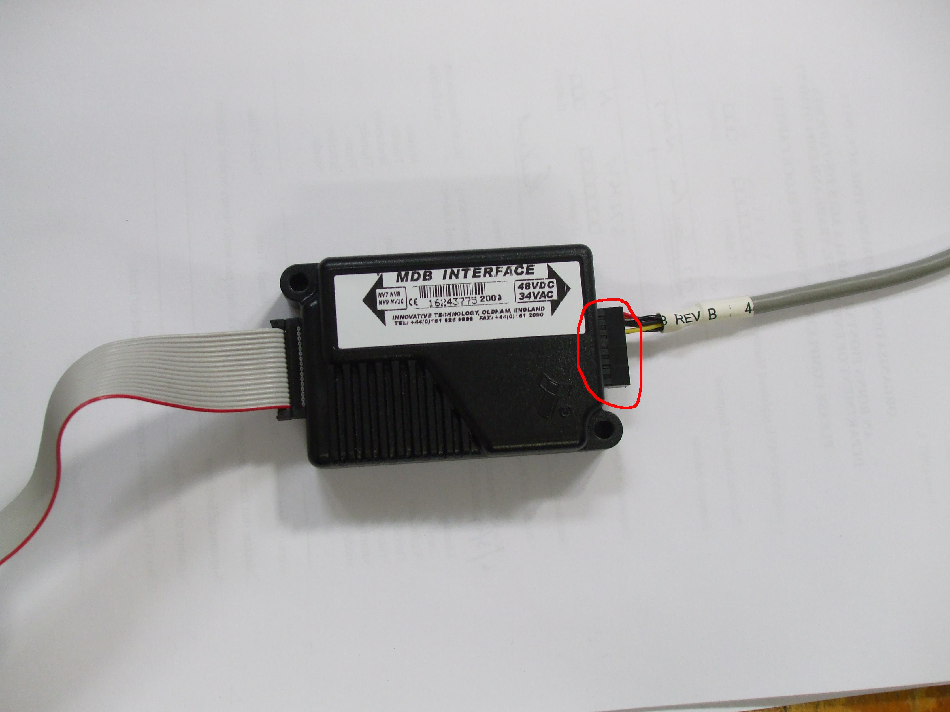
Step 4 – connecting the IF5 cable to the IF5 box
- The IF5 cable has two white connectors – one male and one female. Connect the male connector on the IF5 cable to the female connector on the MDB loom. There is no need to connect the female end of the IF5 cable to anything. See photo below;
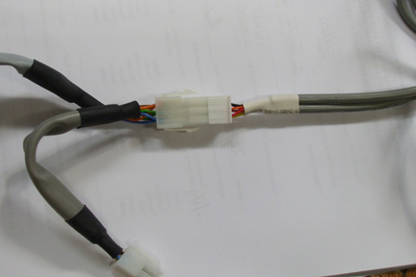
Step 5 – connecting the IF5 cable to the MDB loom

- At the other end of the MDB loom there are three connectors. Connect the small 3way white plug to the bottom socket on the control board and connect the large 4 way white plug to either of the 4-way sockets on the power board. The large white 3 way plug is not used. See photo below:
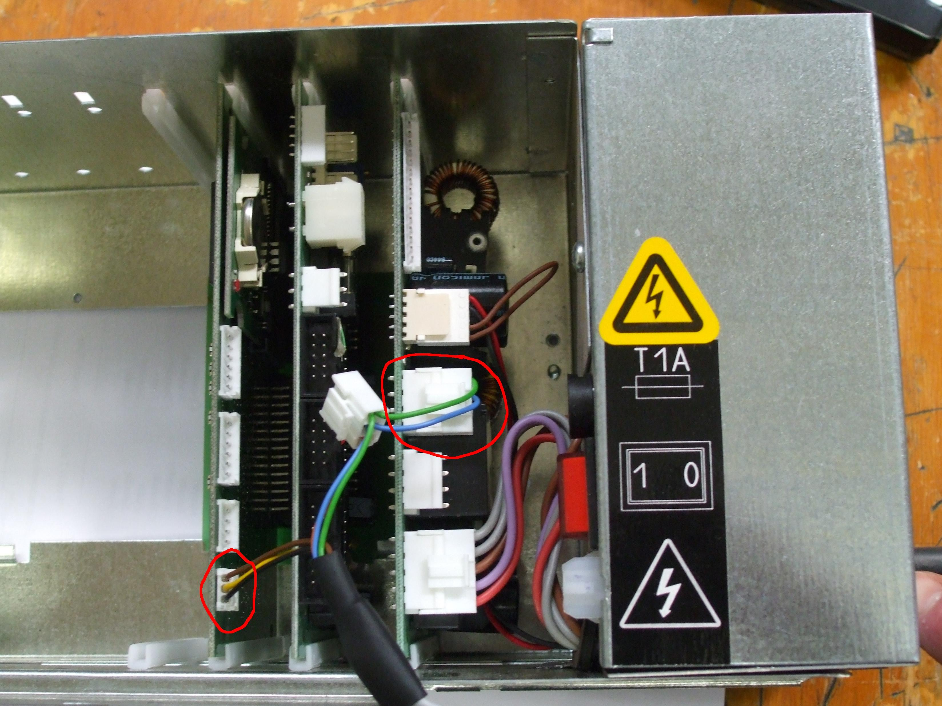
Step 6 – connecting the MDB loom to the boards

- Power on machine.
- Go to programme #220 “freevend” on the basic menu. If this programme is not there, access it through function 000 by holding down button C on the handset and then entering in “220” using buttons A, B & C. Press D to enter the programme.
- Ensure freevend is set to “no”. Button A on the handset switches between “yes” and “no”. Confirm your selection by pressing D on the handset.
- “One tap yes” will now appear on the display. Confirm this by pressing the button. NB – do not change this setting to “one tap no”.
- Go to programme #455 and press D to enter the programme.
- “No bill reader” or “MDB” will appear. Ensure this is set to “MDB” - button A toggles between “no bill reader” and “MDB”. Press D to confirm.
- “Bill 5 ? No” will appear. Change this to “yes” if you wish the machine to accept €5 notes by pressing A. Now press button and repeat the above for €10, €20 and €50 notes.

During use:
If you wish to check what money should be in the note reader at any point, go to programme #149 “money in notes” by holding down button C . Press D to enter the programme. Use programme # 171 “count reset” to clear the data if you wish.

