Installing an Azkoyen Remote Control Unit in a Teide Blue or N-Range machine
- Online video demonstration available in the technical support section of our website.

Before beginning, ensure that you have the necessary equipment – you will need:
- Keyfob;
- Receiver box;
- Remote control loom;
NB – If you are installing in an N-Range you will also need to ensure that the software on the machine is at least version 7 (“-7”). If not you will need to insert an EPROM with the up-to-date software. The Teide Blue comes already equipped with the necessary software.

Installation consists of three steps:
- Install the Receiver box;
- Teach the Keyfob frequency to the remote control;
- Activate the remote control in programme #228;

- Install the Receiver box;
- Switch off the vending machine;
- Connect the remote control loom to the receiver box;
- Connect the 5 pin connection on the loom to the connection on the in/out board of the machine (2nd board from the right) – see figure 1 below;
- Switch on the machine.
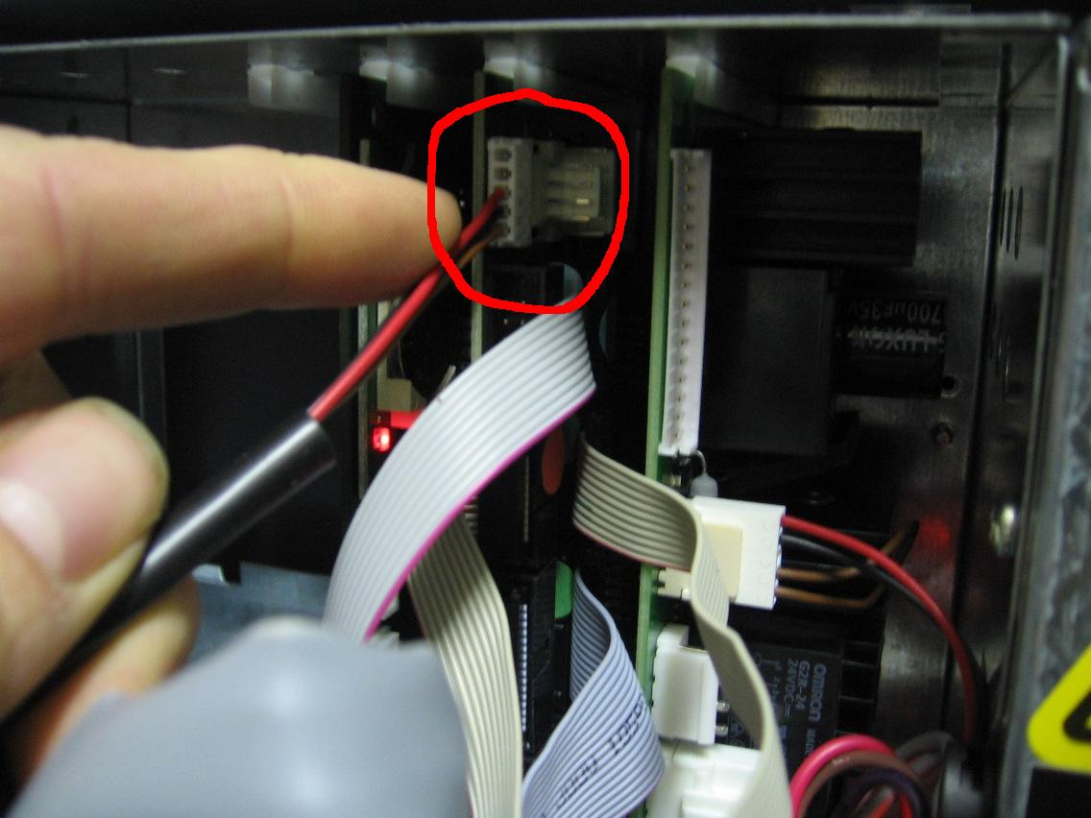
Figure 1 – connection the remote control loom to the in/out board.

- Teach the Keyfob frequency to the remote control;
- Carefully remove the lid from the receiver box;
- Inside the box you will find a small button known as the “learning button” – see figure 2 (PTO);
- Press and hold in the learning button – the LED in the receiver box will flash continually;
- While you are holding the button in, press the button on the keyfob once – now release the button on the receiver box – the keyfob frequency has now been learned;
- Note that up to 3 keyfobs can be taught to a single receiver box;

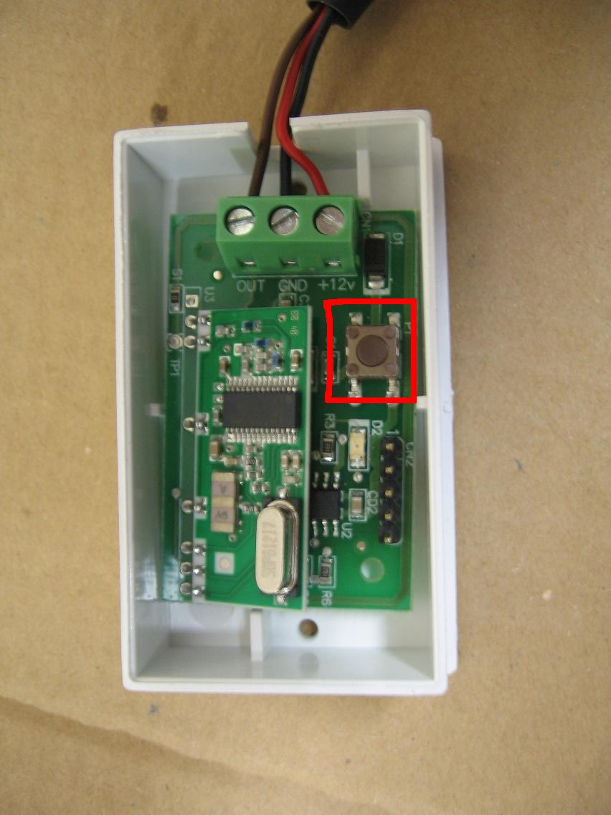
Figure 2 – The “learning button” in the receiver box.

- Activate the remote control in programme #228
- Enter programme #228 in the machine;
- Using the “A” button on the machine handset, choose one of the following 4 options:
  - 1. Free - (both tokens and remote control are turned off with this option);
  - 2. RF – (the machine operates with the remote control only);
  - 3. Token – (the machines operates with tokens only);
  - 4. RF + Token – (the machine will operate with either a token or the remote control).
- When you have the option you desire on screen, press the reject button;
- If you are using an N-Range machine “Time 00” will now appear on the display – press the reject button again;
- Now press “C” on the handset to exit the programming mode.
- Test the operation of the remote control – when you press the keyfob button the display on the screen will show the following:
  - N-Range: “0.00” and the words “select a product” will scroll across the display;
  - Teide Blue: The machine will beep and “insert credit” appears on screen.

Notes re operation of the Azkoyen Remote Control:
- When the remote control button is pressed, the customer has 60 seconds to enter his/her first coin, if no coin is entered within the 60 seconds the machine will revert to inactive mode;
- When the customer does enter the first coin within the 60 second limit, he/she will then be allowed a further 30 seconds to enter the second coin;
- After entering each coin, a further 30 seconds is allowed to either enter another coin or to make a selection – if the customer does nothing for 30 seconds then the machine will reject the coins that have been inserted and return to inactive mode;

