Instructions for installing a Naas Vending remote control system:
The NVS remote control system operates by means of allowing power to the coin validator when the keyfob button is pushed. If the button is not pushed, no power is allowed to the validator and any coins inserted will simply run through. The validator will be activated for either 60 seconds or 120 seconds as decided by the operator – see below for further details.

The remote control kit consists of the following:
- Receiver box with attached LED;
- Two 10-pin looms;
- Keyfob.

To install the system in a vending machine:
- Take the loom in the machine that normally plugs into the validator and connect it into the connection in the receiver box which is not labelled (if you need a longer loom you can use one of the 2 provided);
- Connect one of the spare looms provided into the connection in the receiver box labelled “validator” and connect the other end of the loom into the validator itself;
- Teach the frequency of the keyfob to the receiver box – this can be done as follows:
- Immediately beside the connections on the receiver box you will find the learning button. Press the button once and the LED will light up for 6 seconds.
- During the 6 seconds, press the keyfob button once and the LED will flash 3 times to indicate the frequency has been learned. If for any reason the frequency was not learned, the LED will not flash 3 times.
- The activation period can be set at either 60 seconds or 120 seconds. To switch between the 2, simply hold down the keyfob button for 10 seconds – the LED will then flash to indicate the change has occurred – a single flash indicates the time is now set for 60 seconds while a double flash indicates it is set for 120 seconds.
- The remote control system is now ready to use (remember to ensure that tokens are turned off in the programming of the machine)
- The system also includes an LED which lights when the unit is activated.
- If you wish you can locate the LED in a convenient location on the front of the machine so that the user can see that the machine is activated. This generally involves drilling a hole and using the grommet provided to secure the LED in place.
- See below for more detailed instructions on how to install the system in some of the most common models of machine.

Figure 1: - Situation before remote control is installed:
Validator loom

Validator

1
Figure 2 – Situation after remote control is installed:
Receiver box
Remote ctrl loom

Validator
Validator loom

Azkoyen N-Range, Teide Blue and Panoramic machines:
- Power off the machine and remove the validator from the machine together with the cradle;
- When you remove the cradle you will see the small validator circuit board located behind the position the cradle was in;
- For convenience, carefully remove the 10-pin validator loom from the board and replace it with either of the 2 longer 10-pin looms provided;
- Connect the other end of this loom to the connection on the receiver box which is not labelled;
- Now connect one end of the 2nd loom provided to the connection on the receiver box labelled “validator” and connect the other end to the validator;
- Place the receiver box in a convenient location in the machine – see the pictures below for examples of suitable locations;
- Put the validator and cradle back in position in the machine – (note that if you are using an X6 validator you will need to clip it into its cradle before connecting the loom to it);
- Power on the machine;
- At this point you need to teach the frequency of the keyfob to the receiver box – see above for instructions on this;
- Now test to ensure the remote control system has been set up correctly by pressing the keyfob button – the LED should light up indicating that power is now being provided to the validator – it should now be possible to enter coins.
- The activation period will be set by default at either 60 seconds or 120 seconds – see above for details on how to toggle between the two.
- If you wish to place the LED at the front of the machine, on the N-Range we recommend either immediately above or below the reject button. On the Teide Blue range we recommend a point on the grey panel immediately to the left of the reject button. On the Panoramic we recommend putting it in the clear Perspex immediately above the reject button (you will need to remove one of the LEDs from the circuit board behind to reject button to make room for it).

2
Azkoyen D-Range and S-Range machines:
- Power off the machine and remove and disconnect the validator from the machine;
- Push the validator loom/cable back through the metal validator bracket/cradle so that it is loose in the machine.
- Connect the validator loom to the connection on the receiver box which is not labelled;
- Now connect one end of one of the 10-pin looms provided to the connection on the receiver box labelled “validator”.
- Push the other end of this loom back up through the metal validator cradle/bracket, connect it to the validator and place the validator back in position in the machine (In the case of an S-Range, note that if you are using an X6 validator you will need to clip the validator into its cradle before connecting the loom to it);
- Place the receiver box in a convenient location in the machine – see the pictures below for examples of suitable locations;
- Power on the machine;
- At this point you need to teach the frequency of the keyfob to the receiver box – see above for instructions on this;
- Now test to ensure the remote control system has been set up correctly by pressing the keyfob button – the LED should light up indicating the power is now being provided to the validator – it should now be possible to enter coins.
- The activation period will be set by default at either 60 seconds or 120 seconds – see above for details on how to toggle between the two.
- If you wish to place the LED at the front of the machine, on the D-Range we recommend placing it in the small plastic panel immediately above the reject button. On the S-Range we recommend immediately to the left of the reject button.

3

Example locations for receiver box:

S-Range: N-Range and Teide Blue:
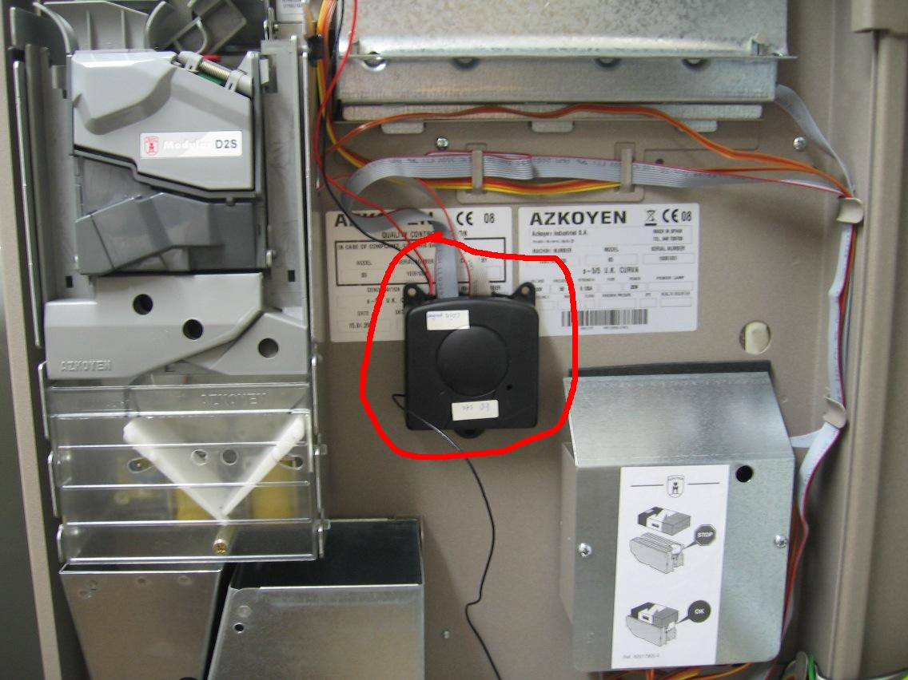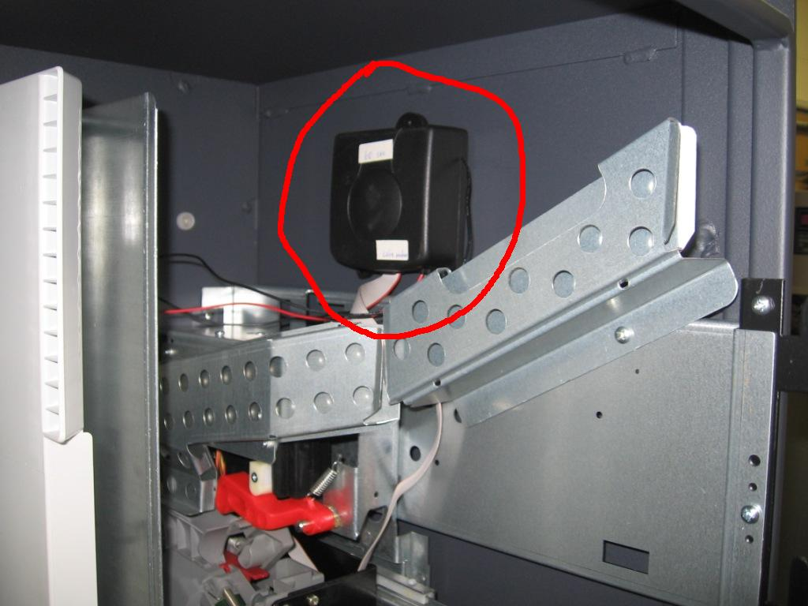

D-6 and D-8: D12/16/23 (with coin mech gate swung open)
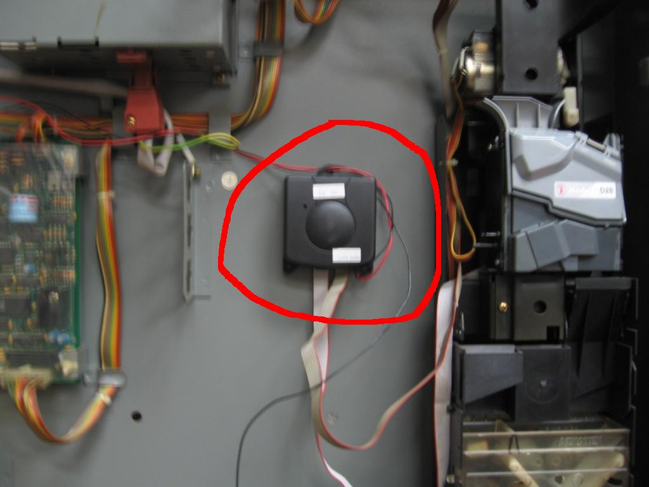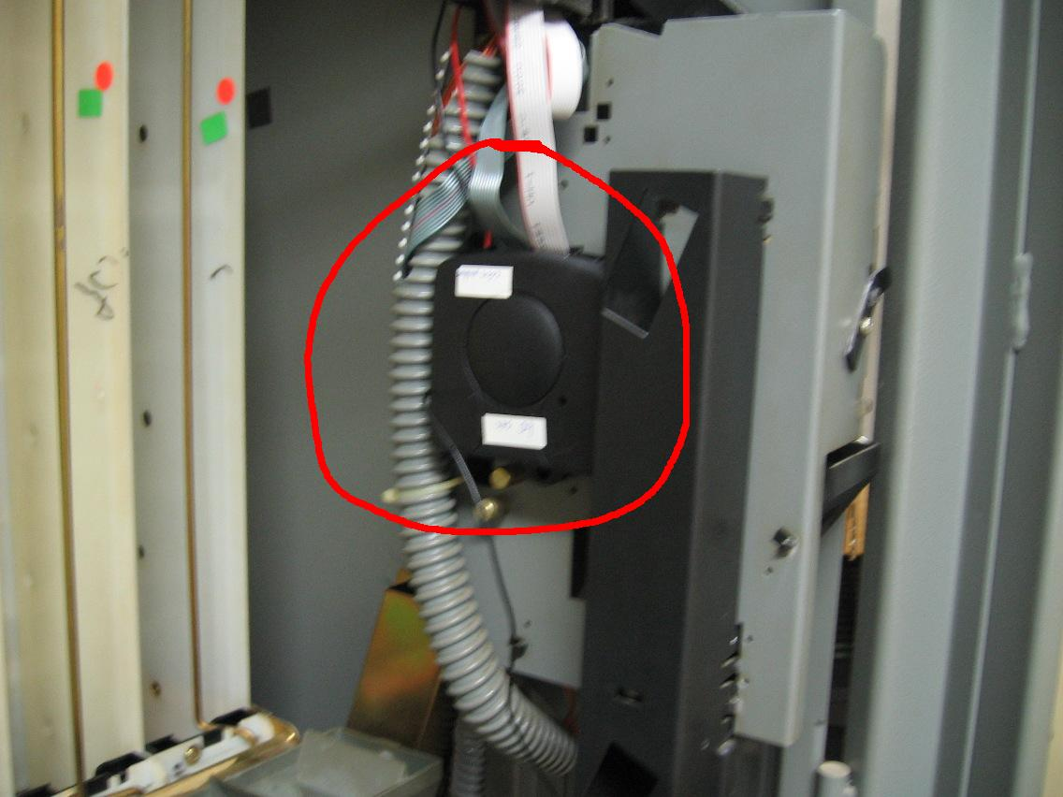

Panoramic:
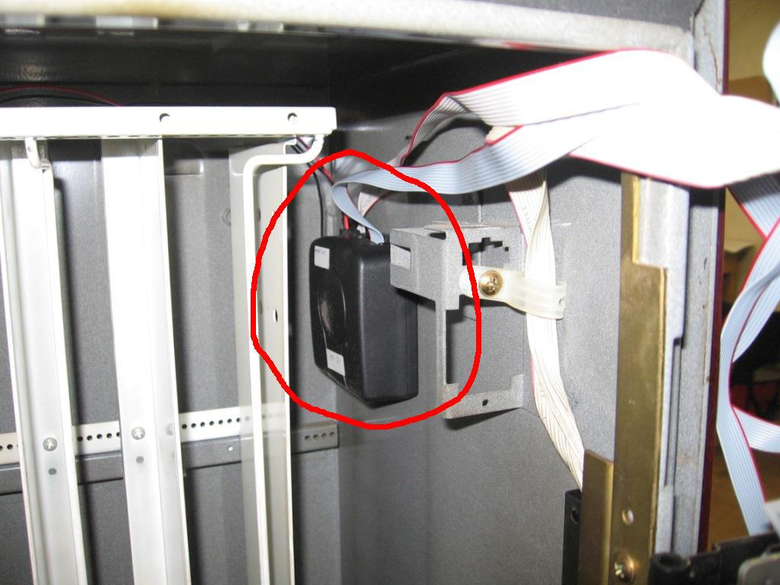

4

